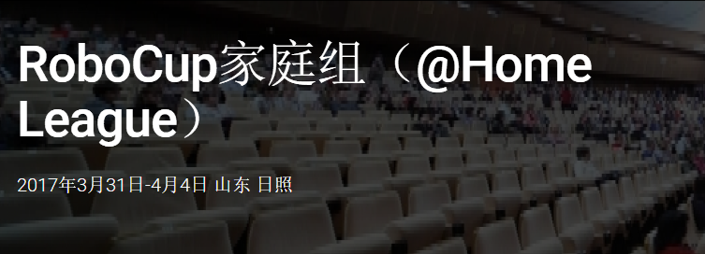

RoboCup家庭组
The RoboCup@Home league aims to develop service and assistive robot technology with high relevance for future personal domestic applications. It is the largest international annual competition for autonomous service robots and is part of the RoboCup initiative. A set of benchmark tests is used to evaluate the robots’ abilities and performance in a realistic non-standardized home environment setting. Focus lies on the following domains but is not limited to: Human-Robot-Interaction and Cooperation, Navigation and Mapping in dynamic environments, Computer Vision and Object Recognition under natural light conditions, Object Manipulation, Adaptive Behaviors, Behavior Integration, Ambient Intelligence, Standardization and System Integration. It is colocated with the RoboCup symposium.
@Home League
RoboCup @ Home 赛事旨在开发对未来个人家庭应用具有高度相关性的服务和辅助机器人技术。 它是服务机器人的最大的年度国际赛事，并且是RoboCup 赛事的一部分。该赛事包括用于在现实的非标准化家庭环境设置中来评估机器人的能力和性能的一组基准测试。 重点在于以下领域，但不限于：在自然光条件下的人机交互和合作，动态环境重的地图自构建与导航，对象操纵，自适应行为，行为集成，环境智能，标准化和系统集成等。

